User Guide  
  
**Introduction**  
  
The Warhammer 40K Unit Efficiency Calculator is designed as a tool to help Warhammer 40k players find the efficiency of their units by calculating the statistical average damage done to targets by a unit. Users are expected to have basic understanding and familiarity with the rules and mechanics of the 40k. It is also assumed that players have access to a Warhammer 40k rulebook (Ninth Edition and Eighth Edition).  
  
**Installation**  
  
The project was made with Google Play download in mind as a goal, however, that method of installation has not been enacted and is unavailable. Please, install using Android Studio and run it using the emulator or download and install onto an Android phone via the .apk file.  
  
**Installing Android Studio for Testing**

1. Java must be installed. Check in terminal with [java --version]
2. Download Android Studio: <https://developer.android.com/studio#downloads>
3. Launch the installer
4. Just click 'next' on every option during installation until you get to 'finish'
5. Once installation is finished, clone this repo and open the project folder in Android Studio
6. To run the emulator, select a device, then click the 'Run app' button  
     
     
     
     
     
     
     
   Instructions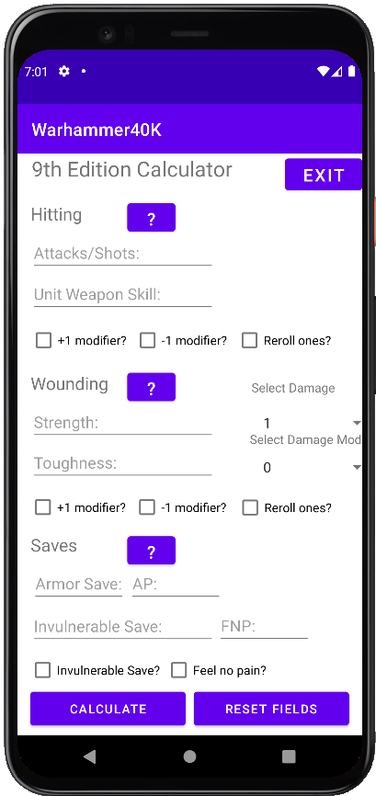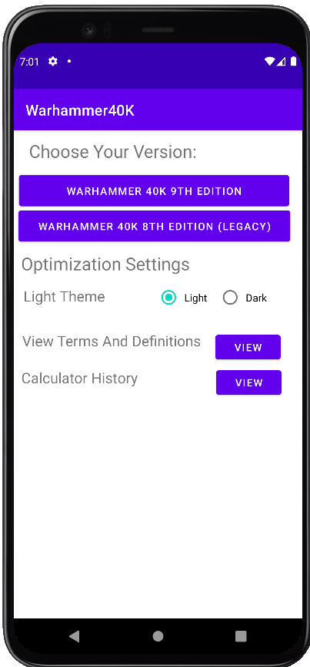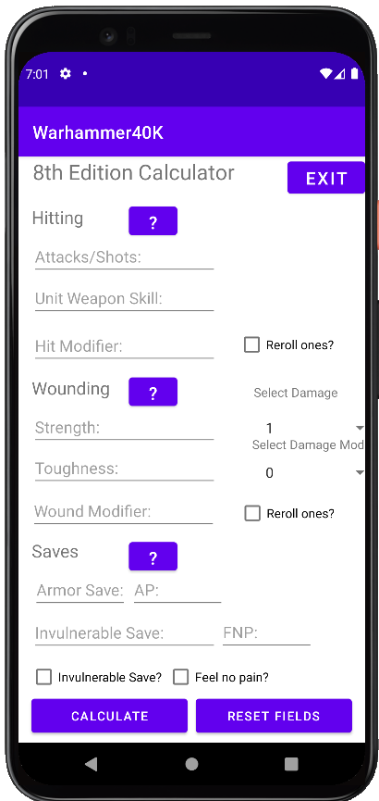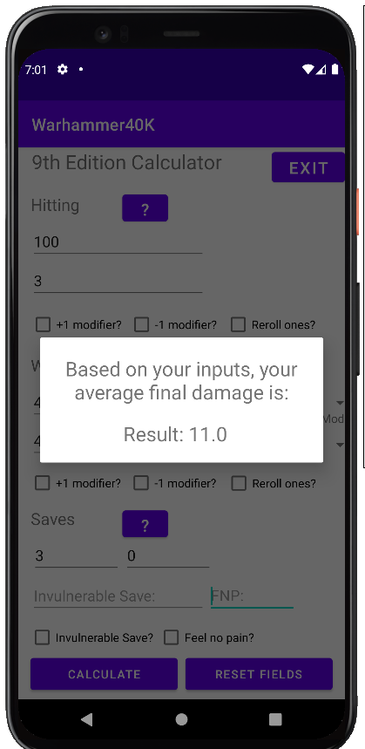

When the app starts up, the user will be greeted with the Version Selection and Optimization Settings Menu.

In Choose Your Version, the user can choose the version of 40k they desire and it will bring them to the calculator input screen. Only the 9th Edition and 8th Edition are available.  
  
Selecting Warhammer 40k 9th Edition will bring the user to the 9th Edition calculator.   
  
Here, the user will need to input their number of Attacks, the Weapons Skill stat of their unit. Then the user should check if reroll ones or any modifiers exist. Hit Modifier exist for the 8th Edition.  
  
Next, the user will enter the Strength and Toughness of their unit and select the Damage and input any in Damage Mods. Wound Modifier exist for the 8th Edition.  
  
Finally the user will input any Armor Save, AP, Invulnerable Save, and/or Feel No Pain, checking the boxes accordingly. Once the user taps Calculate, the calculator will then output the statistical average damage done to a target by the user’s unit.  
  
To clear all inputs, press Clear Field. To exit and return to the Version Selection and Optimization Settings Menu, tap on EXIT.  
  
In the Optimization Settings section, the user can choose between the Light theme or the Dark theme.  
   
 Light Mode: Dark Mode:  
   
  
  
  
  
  
  
  
  
  
  
  
  
By tapping on view for View Terms and Definition, the user will be brought to a list of relevant terms referred to by the calculator and will be able to view each terms’ definitions. Pressing the question marks (?) on the calculator screen will also pop up these definitions.   
  
  
  
  
View Calculator History will store your old inputs and results so that you may review or look at them later.